**PRAKTIKUM ALGORITMA DAN STRUKTUR DATA**

**UAS**



**NAMA : DIMAS ADI BAYU SAMUDRA**

**KELAS : 1A**

**NO. ABSEN : 08**

**NIM : 2341720169**

**PROGRAM STUDI TEKNIK INFORMATIKA**

**JURUSAN TEKNOLOGI INFORMASI**

**POLITEKNIK NEGERI MALANG**

**2024**

**UAS**

Kode Kendaraan08

|  |
| --- |
|  |

Kode TransaksiPajak08

|  |
| --- |
| public class TranksaksiPajak08 {  int kodeTransaksi;  long nominalBayar;  long denda;  int bulanBayar;  Kendaraan08 kendaraan08;  public TranksaksiPajak08(int kodeTransaksi, long nominalBayar, long denda, int bulanBayar, Kendaraan08 kendaraan08) {  this.kodeTransaksi = kodeTransaksi;  this.nominalBayar = nominalBayar;  this.denda = denda;  this.bulanBayar = bulanBayar;  this.kendaraan08 = kendaraan08;  }  } |

Kode Node08

|  |
| --- |
| public class Node08 {  Kendaraan08 kendaraan;  TranksaksiPajak08 TranksaksiPajak;  Node08 next, prev;  Node08(Kendaraan08 kendaraan ,TranksaksiPajak08 TranksaksiPajak , Node08 prev, Node08 next){  this.kendaraan = kendaraan;  this.TranksaksiPajak = TranksaksiPajak;  this.next = next;  this.prev = prev;  }    Node08(Kendaraan08 kendaraan, Node08 prev, Node08 next) {  this.kendaraan = kendaraan;  this.next = next;  this.prev = prev;  }  } |

Kode DLL08

|  |
| --- |
| import java.util.List;  class DLL08 {  Node08 head;  int size;  public DLL08() {  head = null;  size = 0;  }  public boolean isEmpty() {  return head == null;  }  public void add(Kendaraan08 kendaraan) {  Node08 newNode = new Node08(kendaraan, null, null);  if (isEmpty()) {  head = newNode;  } else {  Node08 current = head;  while (current.next != null) {  current = current.next;  }  current.next = newNode;  newNode.prev = current;  }  size++;  }  public void printAllKendaraan() {  Node08 current = head;  while (current != null) {  System.out.println(current.kendaraan);  current = current.next;  }  }  public TranksaksiPajak08 bayarPajak(String tnkb, int bulanBayar, int kodeTransaksi) {  Node08 current = head;  while (current != null && !current.kendaraan.noTNKB.equals(tnkb)) {  current = current.next;  }  if (current == null) {  System.out.println("Kendaraan tidak ditemukan.");  return null;  }  Kendaraan08 kendaraan = current.kendaraan;  long nominalBayar = 0;  long denda = 0;  if (kendaraan.jenis.equalsIgnoreCase("Motor")) {  if (kendaraan.cc < 100) {  nominalBayar = 100000;  } else if (kendaraan.cc <= 250) {  nominalBayar = 250000;  } else {  nominalBayar = 500000;  }  } else if (kendaraan.jenis.equalsIgnoreCase("Mobil")) {  if (kendaraan.cc < 1000) {  nominalBayar = 750000;  } else if (kendaraan.cc <= 2500) {  nominalBayar = 1000000;  } else {  nominalBayar = 1500000;  }  }  int bulanHarusBayar = kendaraan.bulanHarusBayar;  if (bulanBayar > bulanHarusBayar) {  int selisihBulan = bulanBayar - bulanHarusBayar;  if (selisihBulan <= 3) {  denda = selisihBulan * 50000;  } else {  denda = 3 * 50000 + (selisihBulan - 3) * 50000;  }  }  System.out.println("==================================");  System.out.println("Data Pembayaran");  System.out.println("==================================");  System.out.printf("| %-4s | %-11s | %-10s | %-7s | %-7s |%n", "No", "TNKB", "Nama", "Nominal", "Denda");  System.out.printf("| %-4d | %-11s | %-10s | %-7d | %-7d |%n", 1, kendaraan.noTNKB, kendaraan.nama, nominalBayar, denda);  System.out.println("==================================");  return new TranksaksiPajak08(kodeTransaksi, nominalBayar, denda, bulanBayar, kendaraan);  }  public void printAllTransaksi(List<TranksaksiPajak08> transaksiList) {  long totalPemasukan = 0;  System.out.println("+++++++++++++++++++++++++++");  System.out.println("Daftar Transaksi Pembayaran Pajak");  System.out.println("+++++++++++++++++++++++++++");  System.out.println("|kode|TNKB |Nama |Nominal |Denda |");  System.out.println("-------------------------------------------------");  if (transaksiList.isEmpty()) {  System.out.printf("| %-4s | %-46s |%n", "", "Data Transaksi atau Kendaraan Kosong");  } else {  int kode = 1;  for (TranksaksiPajak08 transaksi : transaksiList) {  if (transaksi != null && transaksi.kendaraan08 != null) {  System.out.printf("|%-4d|%-11s|%-10s|%-8d|%-8d|%n",  kode++, transaksi.kendaraan08.noTNKB, transaksi.kendaraan08.nama,  transaksi.nominalBayar, transaksi.denda);  totalPemasukan += transaksi.nominalBayar + transaksi.denda;  } else {  System.out.printf("|%-4d| %-46s |%n", kode++, "Data Transaksi atau Kendaraan Kosong");  }  }  }  System.out.println("-------------------------------------------------");  System.out.println("semua transaksi berhasil dicetak");  System.out.println("+++++++++++++++++++++++++++");  System.out.printf("TOTAL PENDAPATAN%n+++++++++++++++++++++++++++%nPendapatan hari ini : %d%n", totalPemasukan);  }  } |

Kode Main08

|  |
| --- |
| import java.util.ArrayList;  import java.util.List;  import java.util.Scanner;  public class Main08 {  public static void main(String[] args) {  Scanner sc = new Scanner(System.in);  DLL08 list = new DLL08();  List<TranksaksiPajak08> transaksiList = new ArrayList<>();  Kendaraan08 k1 = new Kendaraan08("S 4567 YV", "Basko", "Mobil", 2000, 2012, 4);  Kendaraan08 k2 = new Kendaraan08("N 4511 VS", "Arta", "Mobil", 2500, 2015, 3);  Kendaraan08 k3 = new Kendaraan08("AB 4321 A", "Wisnu", "Motor", 125, 2010, 2);  Kendaraan08 k4 = new Kendaraan08("B 1234 AG", "Sisa", "Motor", 150, 2020, 1);  list.add(k1);  list.add(k2);  list.add(k3);  list.add(k4);  int pilih;  do {  System.out.println("Menu ");  System.out.println("1. Daftar Kendaraan ");  System.out.println("2. Bayar Pajak ");  System.out.println("3. Tampil Seluruh Transaksi ");  System.out.println("4. Urutkan Transaksi Berdasar nama Pemilik");  System.out.println("5. Keluar");  System.out.print("Pilih (1-5): ");  pilih = sc.nextInt();  switch (pilih) {  case 1:  System.out.println("+++++++++++++++++++++++++++");  System.out.println("Daftar Kendaraan");  System.out.println("+++++++++++++++++++++++++++");  System.out.println("| Nomor TNKB |Nama Pemilik|Jenis |CC Kendaraan|Tahun|Bulan Harus Bayar|");  System.out.println("-------------------------------------------------------------------------");  list.printAllKendaraan();  break;  case 2:  System.out.println("+++++++++++++++++++++++++++");  System.out.println("Daftar Kendaraan");  System.out.println("+++++++++++++++++++++++++++");  System.out.println("| Nomor TNKB |Nama Pemilik|Jenis |CC Kendaraan|Tahun|Bulan Harus Bayar|");  System.out.println("-------------------------------------------------------------------------");  list.printAllKendaraan();  System.out.print("Masukkan Nomer TNKB: ");  sc.nextLine(); // consume newline  String tnkb = sc.nextLine();  System.out.print("Bulan Bayar: ");  int bulanBayar = sc.nextInt();  TranksaksiPajak08 transaksi = list.bayarPajak(tnkb, bulanBayar, transaksiList.size() + 1);  if (transaksi != null) {  transaksiList.add(transaksi);  }  break;  case 3:  list.printAllTransaksi(transaksiList);  break;  case 4:  // Implement case 4 logic here  break;  case 5:  System.out.println("Terima kasih telah menggunakan layanan kami.");  break;  default:  System.out.println("Pilihan tidak valid");  break;  }  } while (pilih != 5);  sc.close();  }  } |

Hasil Run

1. menu

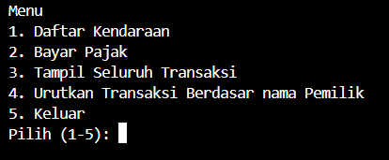

Menu 1

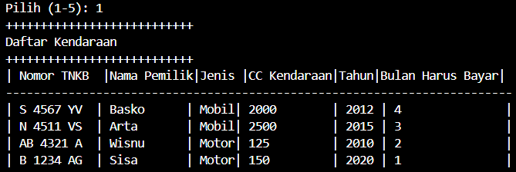

Menu 2

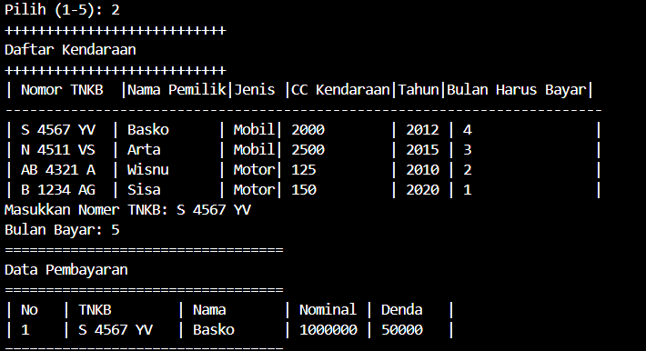

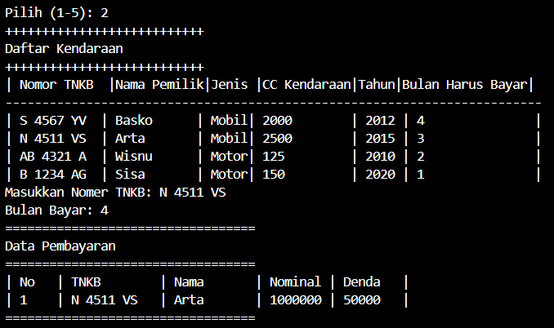

Menu 3

